**Green Society Public School**

**D-04**

**Ratnanagar-7, Sauraha, Chitwan**

**Second Terminal Examination-2082**

**Class: UKG Time: - 2 hrs. F.M.: 50**

**Sub: Social Science**

|  |
| --- |
| **Name: Roll No.: Sec.:** |
| **­­­­­­­­­­­­ ________________ ______________ OBT.MARKS:**  **INVIGILATOR EXAMINER** |

1. **Write the name of birds? (3)**

…………………. …………………. ……………………….

1. 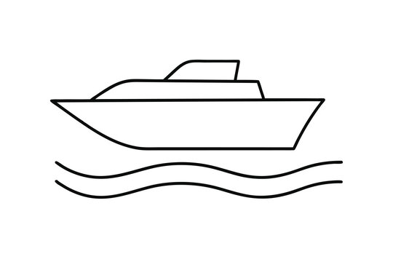**Write the name of water transports? (3)**

1. **Write the name of flowers? (3)**

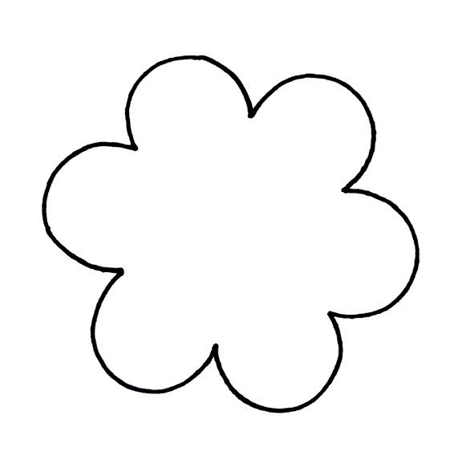

…………………. …………………. ……………………….

1. 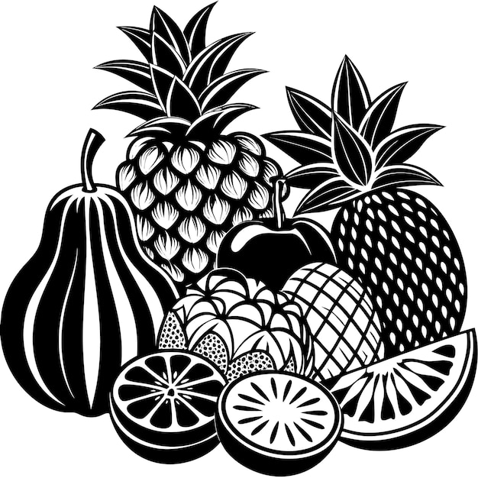**Write the name of fruits? (4)**
2. 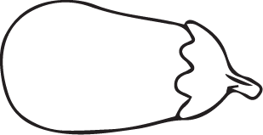**Write the name of vegetable? (4)**
3. **Write the name of water animal? (4)**

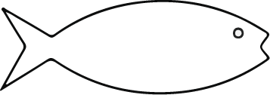

1. **Match the sense organs to their function. (5)**

|  |  |  |
| --- | --- | --- |
|  |  | Joyful Boy Listening to Music with Headphones Surrounded by Nature for  Coloring or Tattoo Design 60229516 Vector Art at Vecteezy |
|  |  |  |
|  |  |  |
|  |  |  |
|  |  |  |

1. 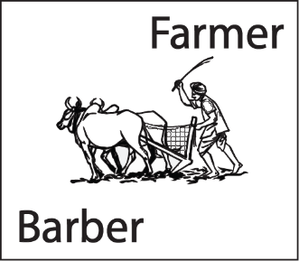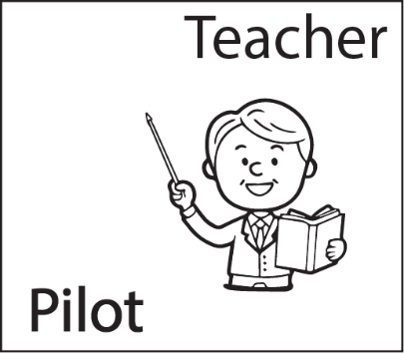**Look at the picture and circle the correct word? (5)**

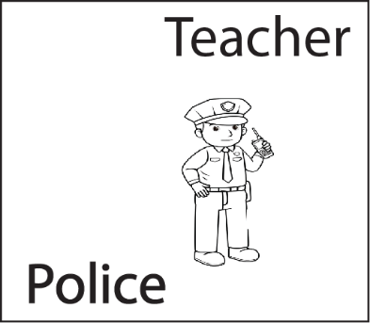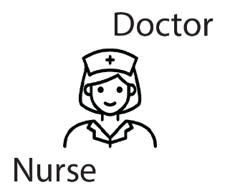

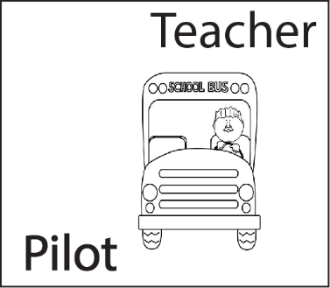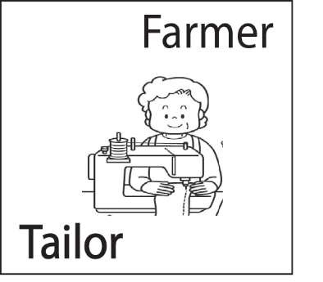

1. **Write down 3/3 living things and non-living things. (6)**

|  |  |
| --- | --- |
| **Living things** | **Non-living things** |
|  |  |
|  |  |
|  |  |

1. 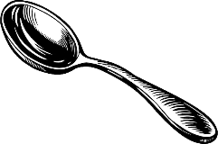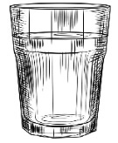**Write name of the given picture. (5)**

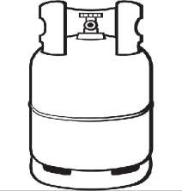

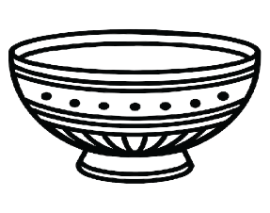

**The End**